Design Project Part 1 Spring 2020

Finding and Buying Used Car Parts from Junkyards

CMPS 482 Current Trends in Computer Science

Participants: Matt Carter, Eric Homiak, Josh Miller, and Victoria Murphy

Instructor: Dr. Cris Koutsougeras

Scope

This website sets out to help the used automotive parts industry by creating an easy and efficient way for consumers to get the parts that they need and for the seller to keep track of the inventory that they have. Instead of consumers sacrificing price for convenience at a retail automotive store or convenience for price by searching numerous junkyards, this website brings the price and convenience together so there is no sacrifice. They will be able to filter out the parts they require near them and make only one stop while paying the junkyard price.

Functional Requirements

The one stop shop website will include a user interface that will be functional and user friendly. The location for the search area can easily be obtained by entering the zip code, city or current location. Also included in the location search area will be a radius from point searched, allowing the user to drag on a map. The website functions will effectively enable the user to search for automotive parts, either at a junkyard or a retail automotive store.

The user will be able to control the search of parts by entering a make and model, part number or keyword, and the condition. A list of parts that match the search criteria will be displayed for the user. The user will then be able to compare prices and make the purchase immediately at the checkout area after determining which part they would like to purchase.

Functions

The capabilities of this website will have limitless benefits. The user will find it to be beneficial to limit their search to a specific area and for a specific part. The method of search will return a list of parts that matches the users specifications and allow the user to easily narrow their search. The customer will be able to buy car parts from sellers or junkyards. The user is also offered the choice of making an account for future reference or to sign in as a guest.

Specifications

* Search functionality
* Purchase functionality
* Listing functionality
* Inventory functionality

Home Screen/Basic Search

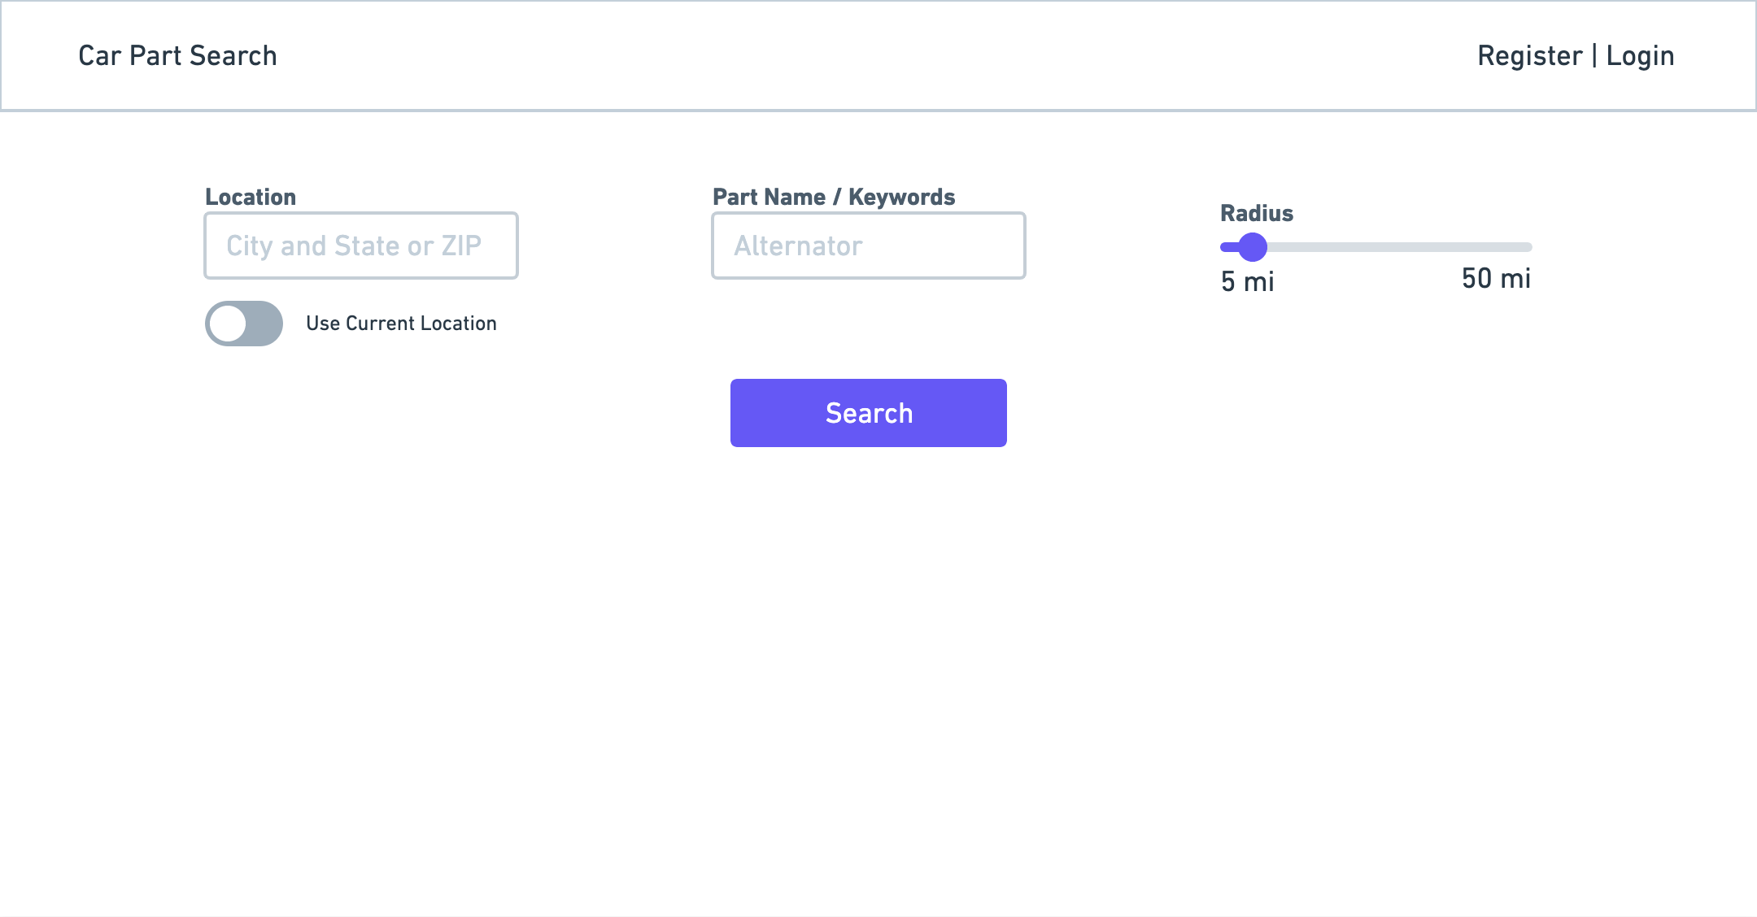

Advanced Search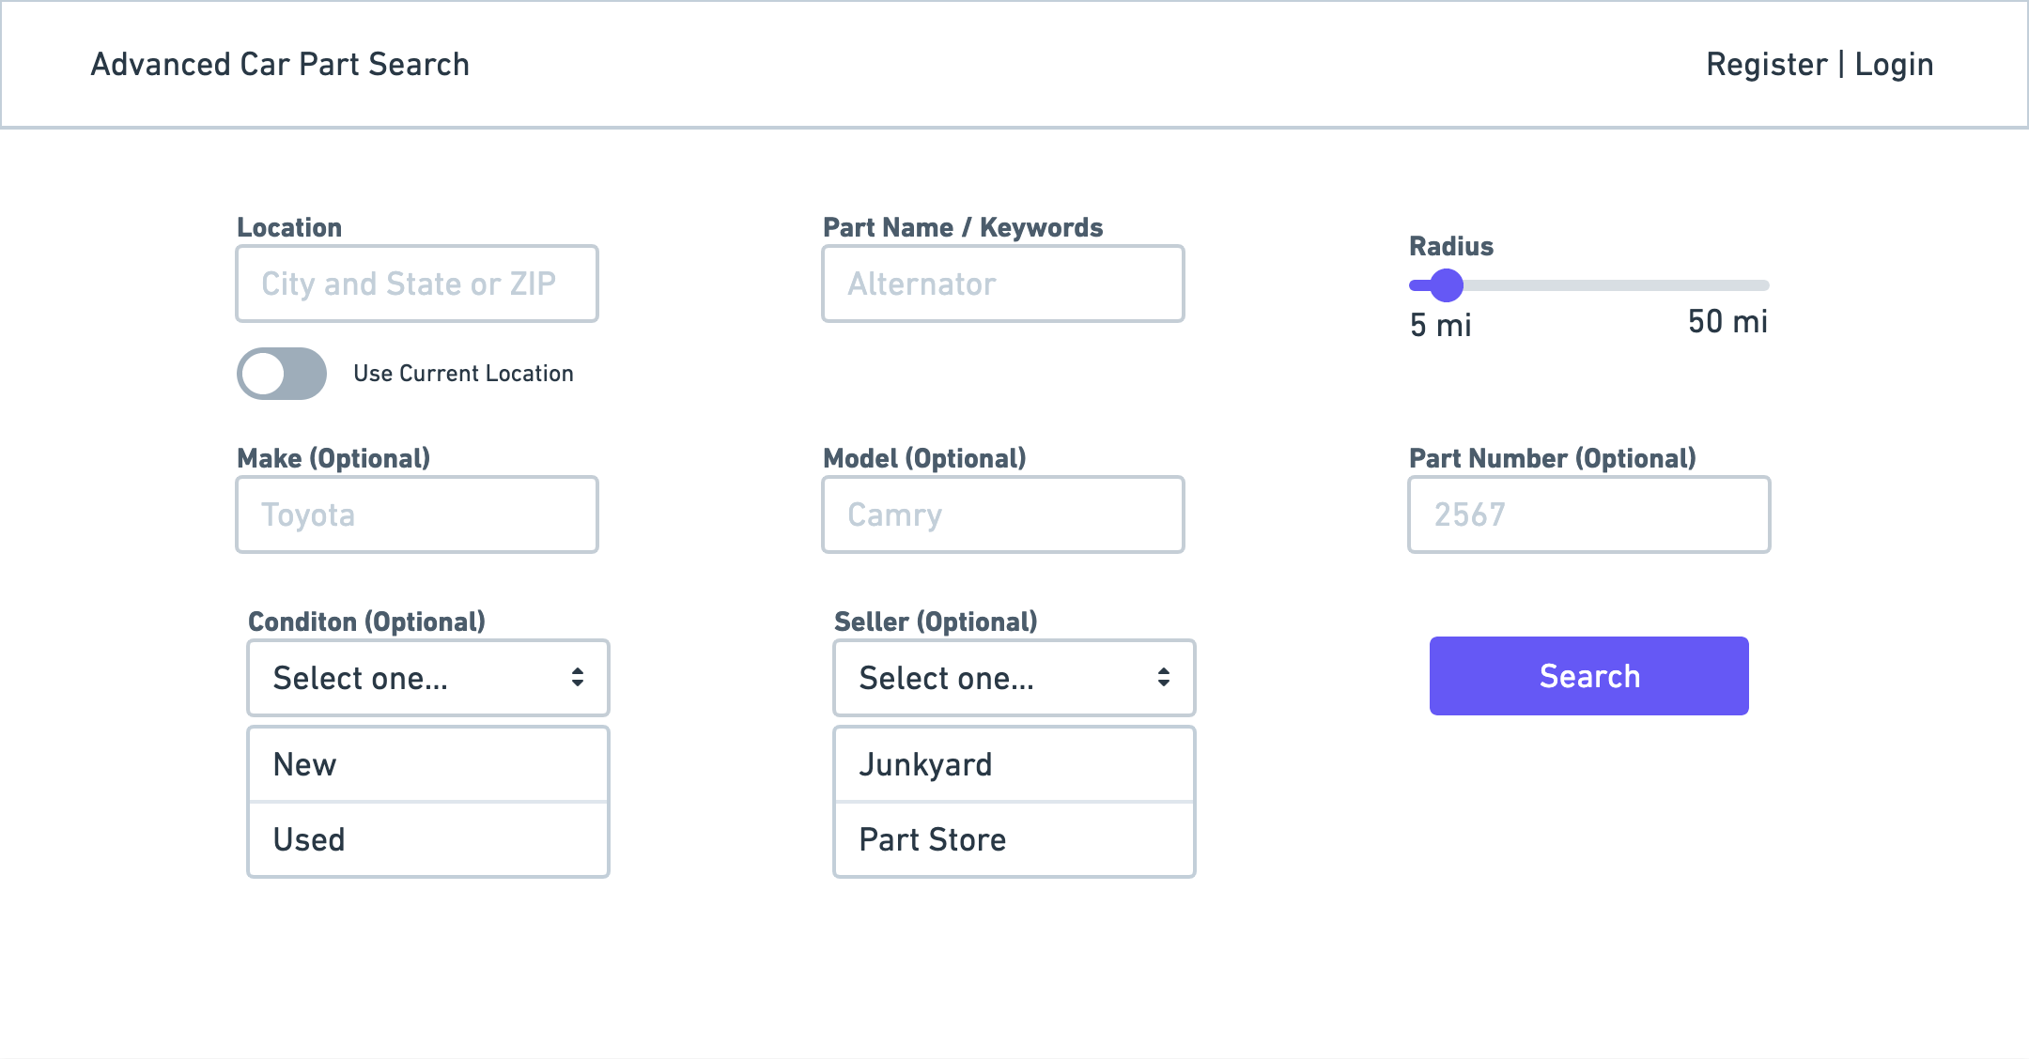

Results Page